Project Development Delivery of Sprint-3

Step1: Login Into MIT App Inventor.

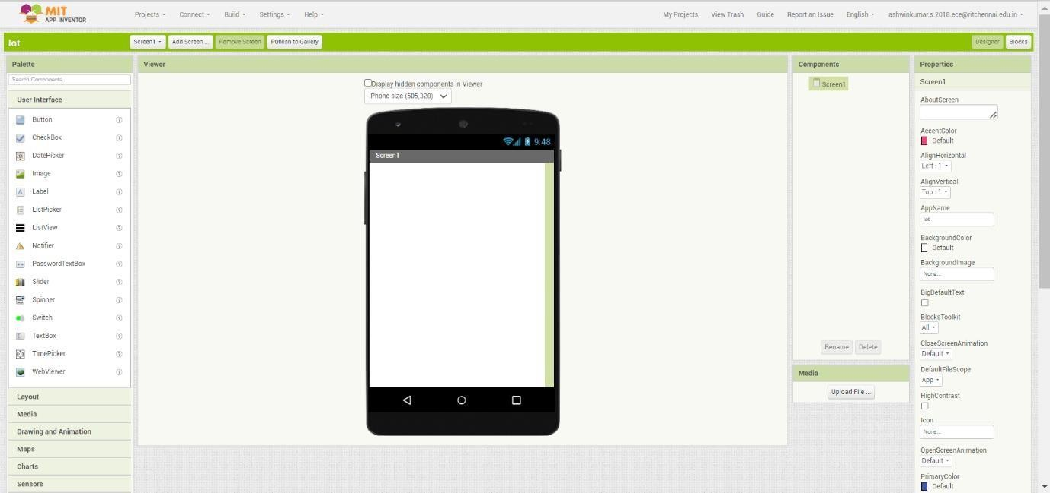

Step:2 Create Your User Interface By Using the Preset Tools.

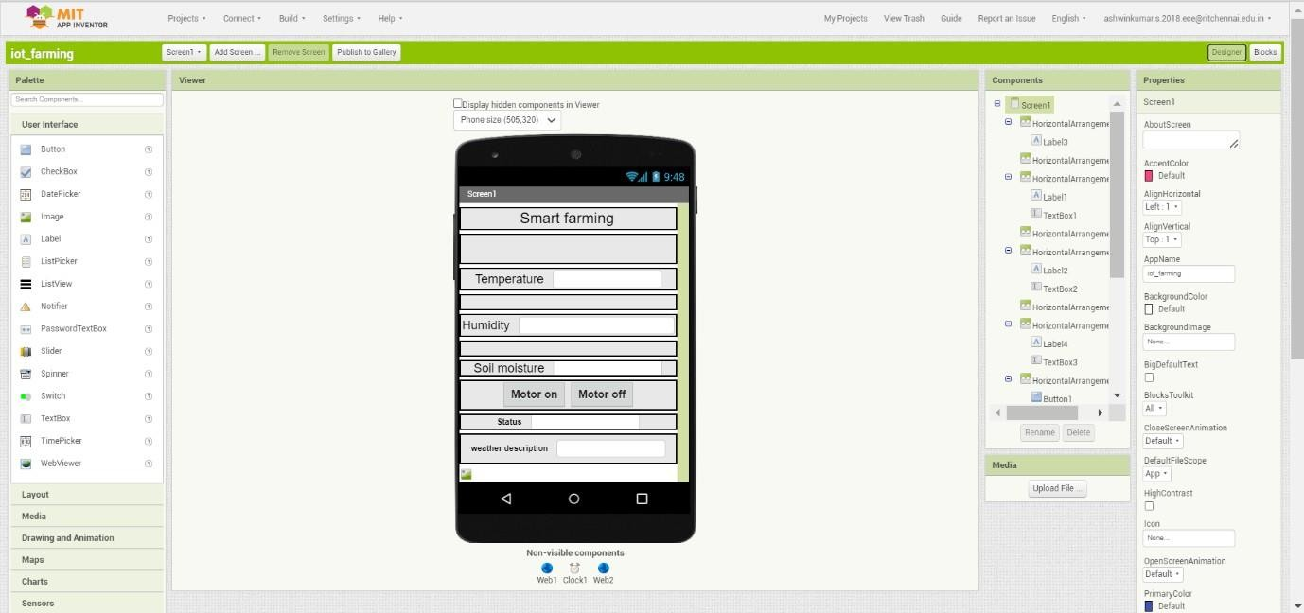

Step:3 Back End Process

* **Specify the Cloud URL Details to Receive the Date From Node Red.**
* **Commend Request From App To Node RED to Turn ON /OFF Motor.**
* **Weather API Data is Displaced From Node RED.**

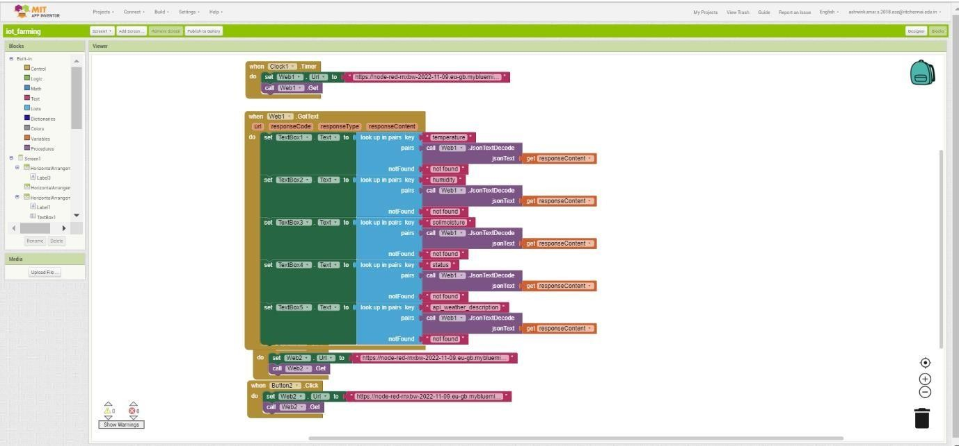

Step:4 Live Output In Mobile Application